**Ссылка на этот шаблон:**

[**https://docs.google.com/document/d/1F5WoANl5qx5H0c3fEKzCWR0gzAMP-7pp/edit?usp=drive_link&ouid=111923301969549531648&rtpof=true&sd=true**](https://docs.google.com/document/d/1F5WoANl5qx5H0c3fEKzCWR0gzAMP-7pp/edit?usp=drive_link&ouid=111923301969549531648&rtpof=true&sd=true)

Зубков Виктор, 5-я когорта, диплом

**Задание 1: Теория тестирования**

1. Ссылка на гугл-таблицу:

<https://docs.google.com/spreadsheets/d/19QZSEcCHFzi6zinx4MH5z7t4trUmvGBr/edit?usp=drive_link&ouid=111923301969549531648&rtpof=true&sd=true>

**Задание 2: Веб-приложение Яндекс.Самокат**

1. Mindmap: https://drive.google.com/file/d/1Bylb7PBOUnBj42z_1q9koyKyiUq8TtL7/view?usp=drive_link

**Интерфейс**

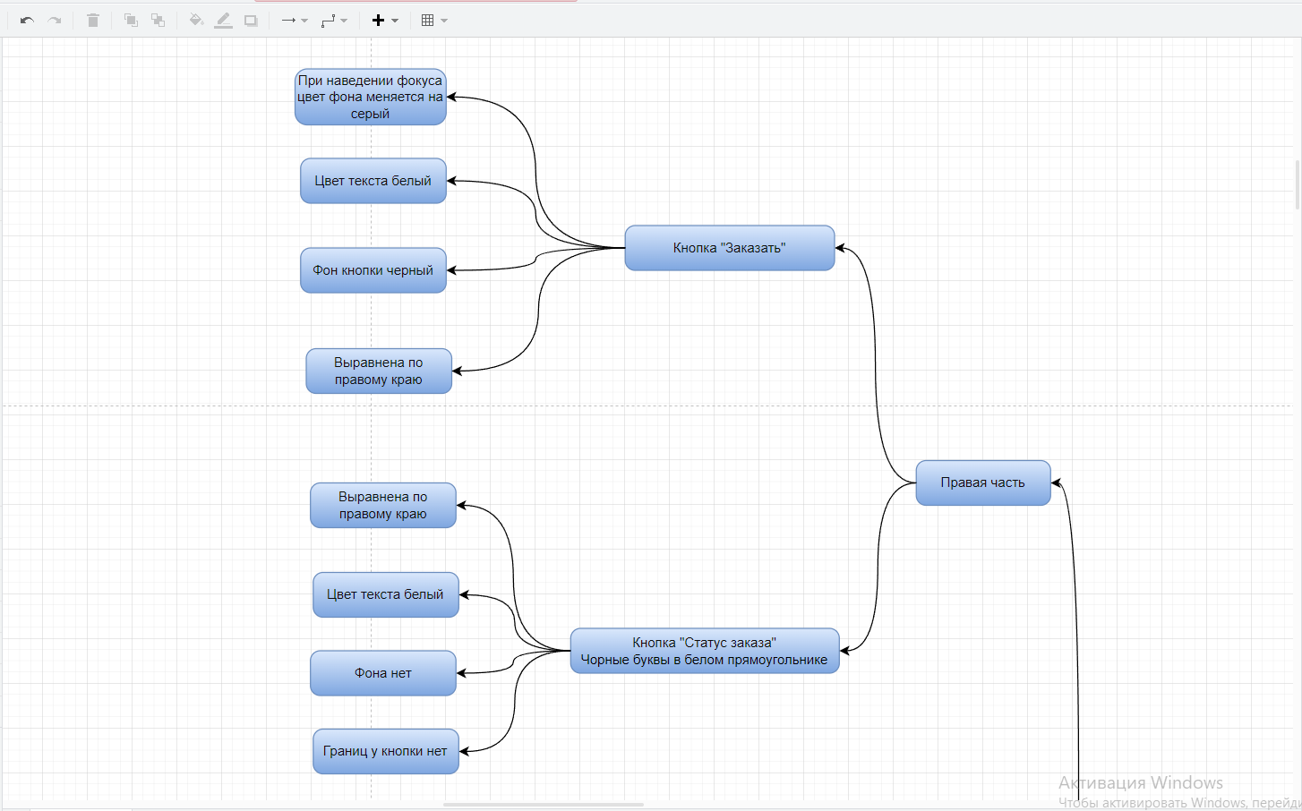

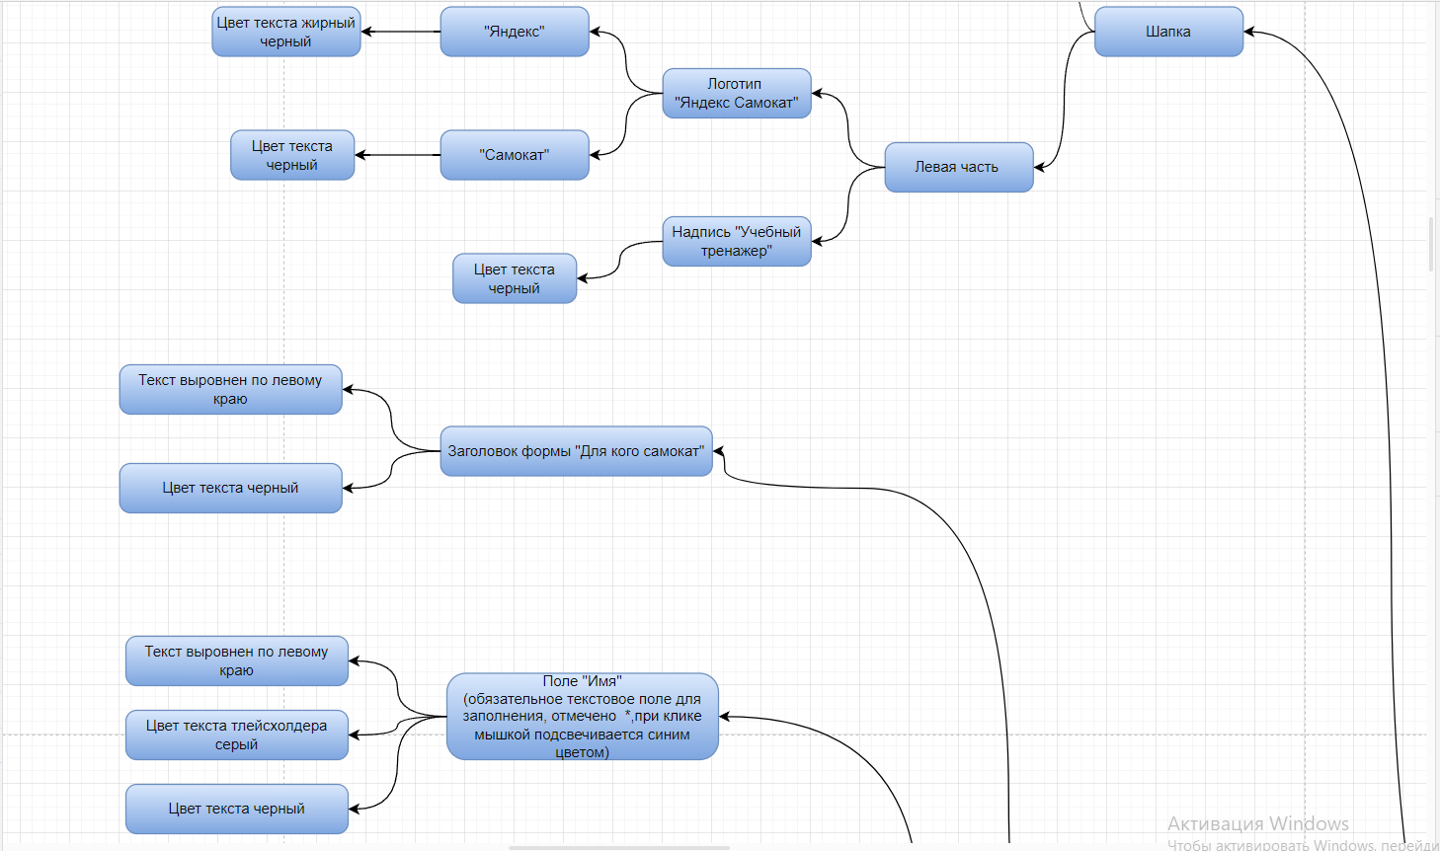

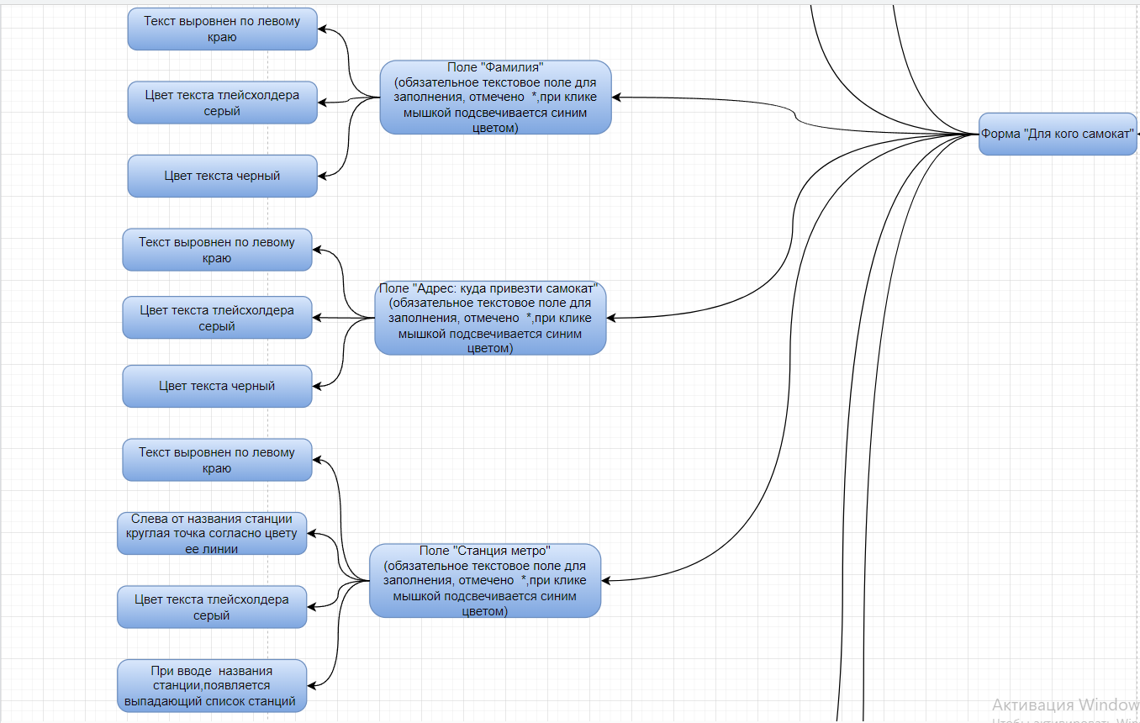

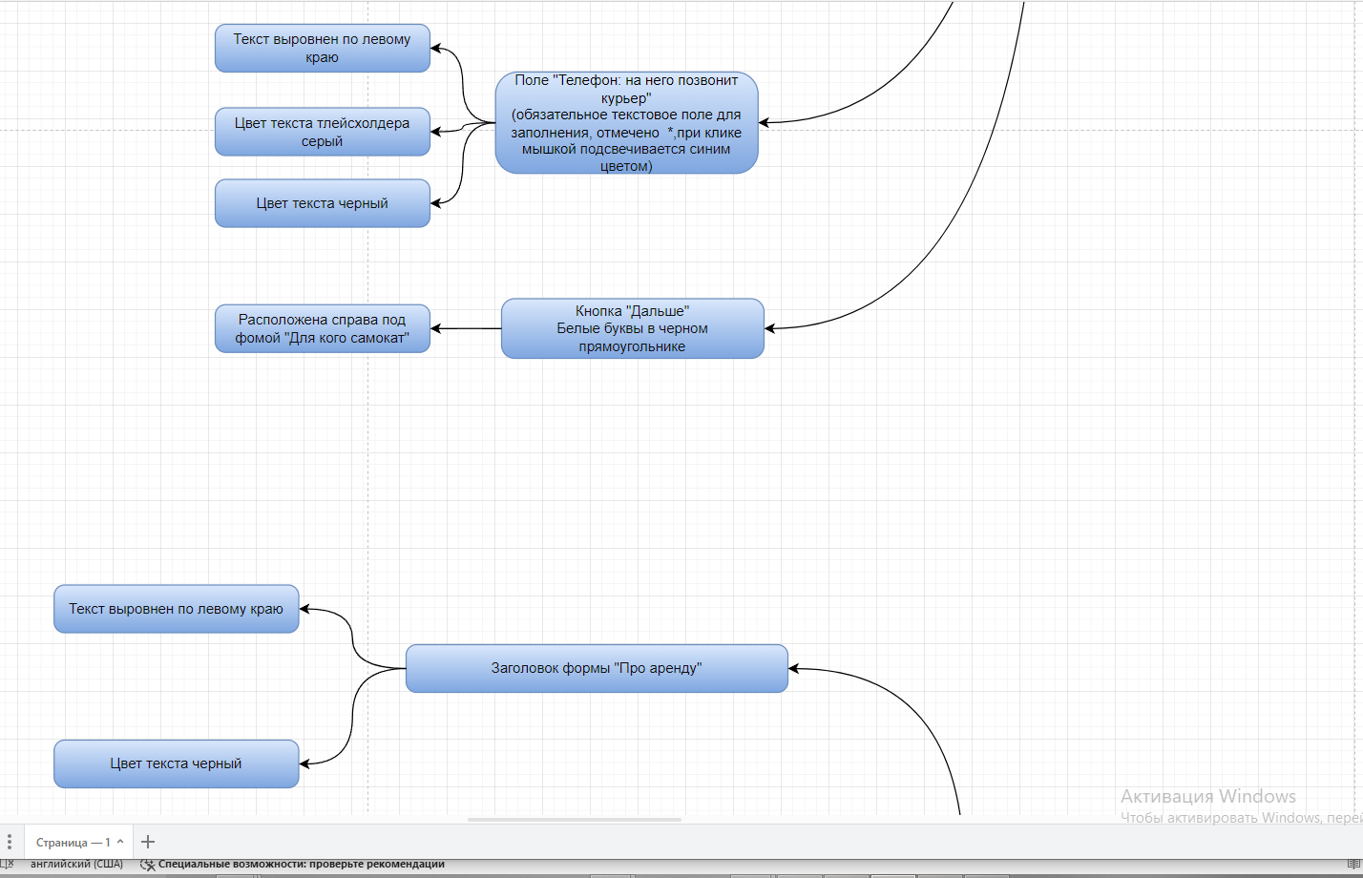

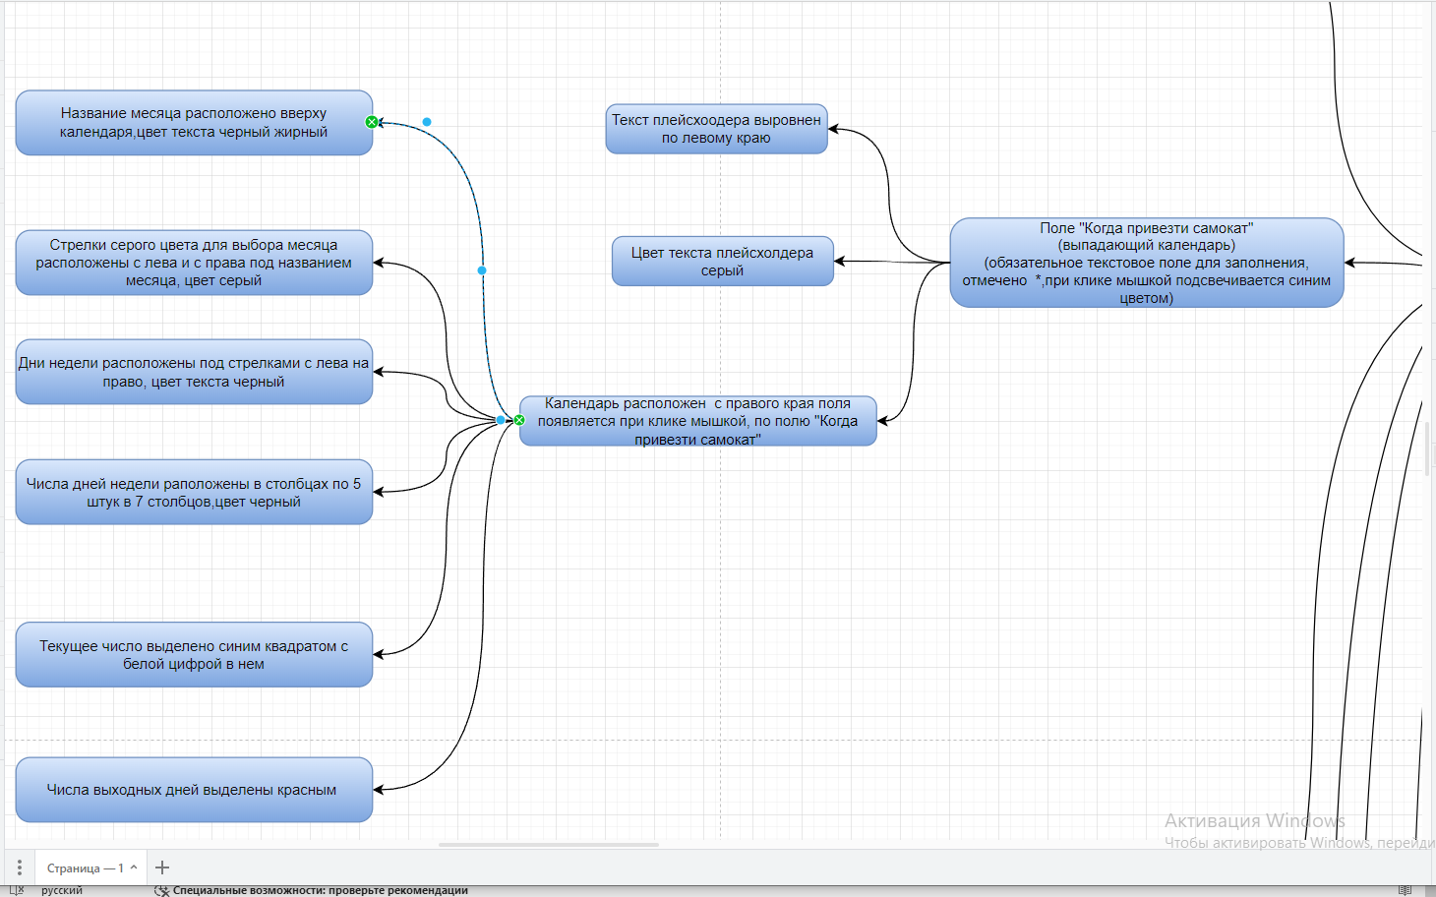

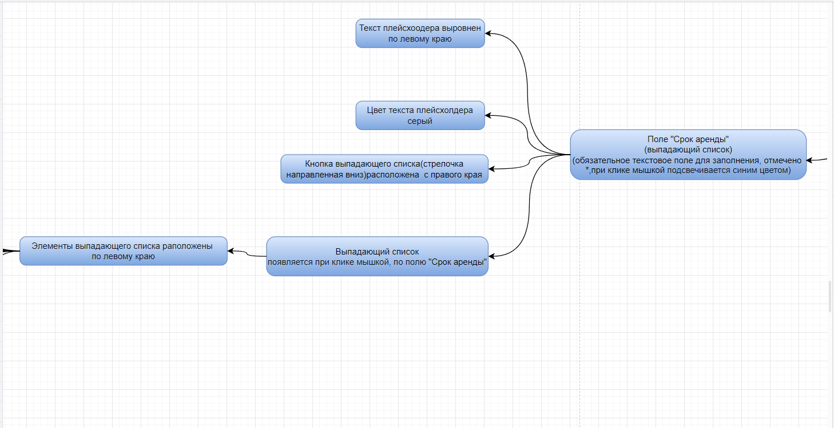

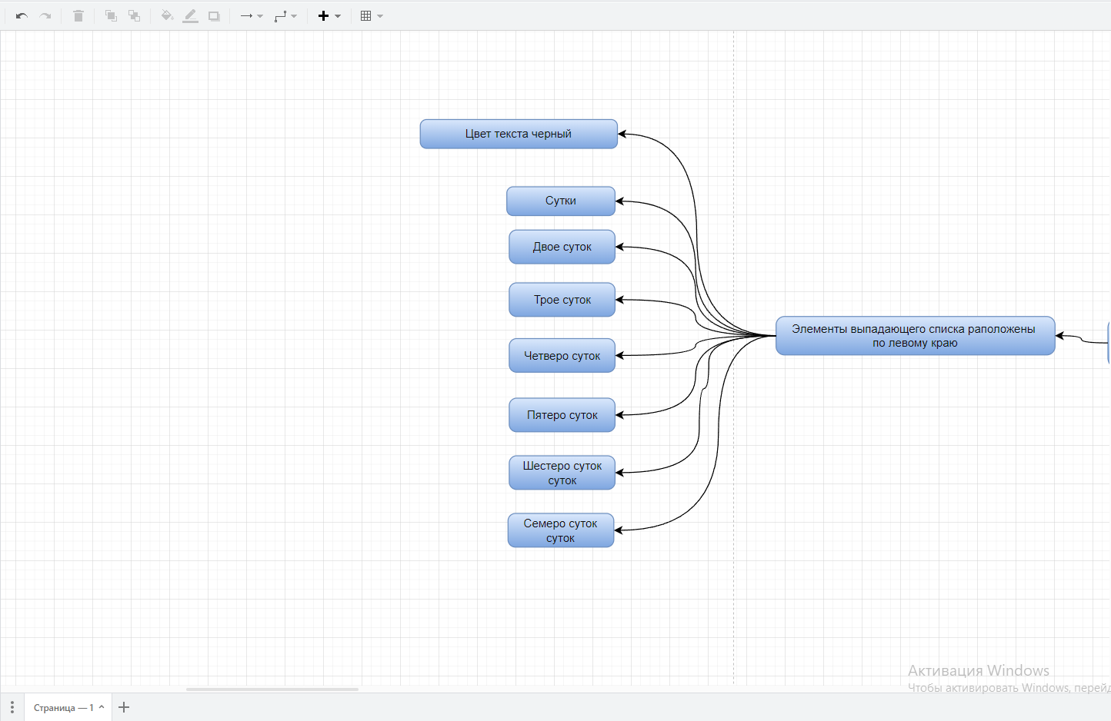

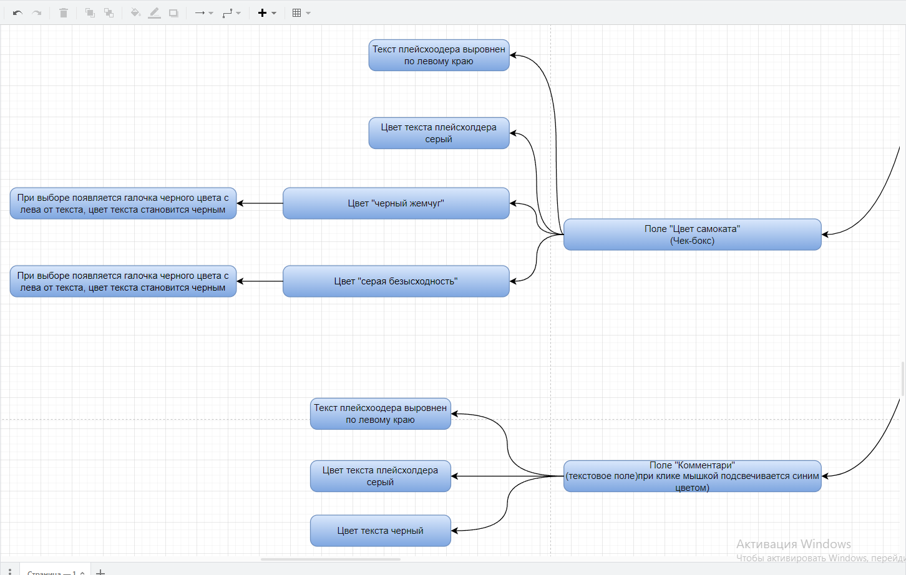

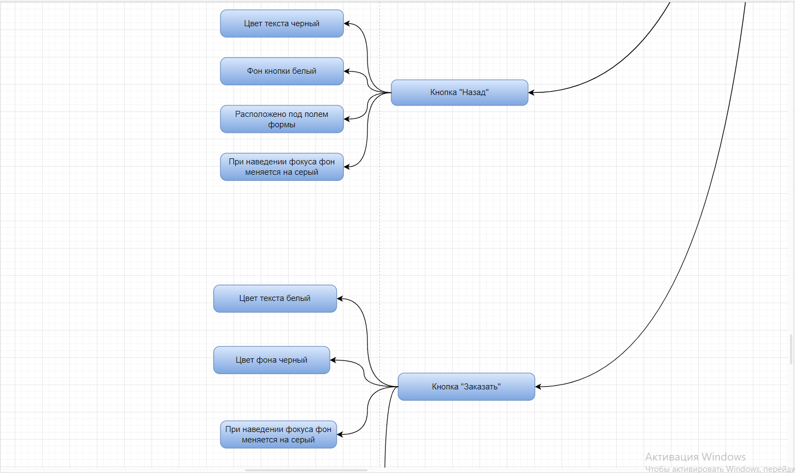

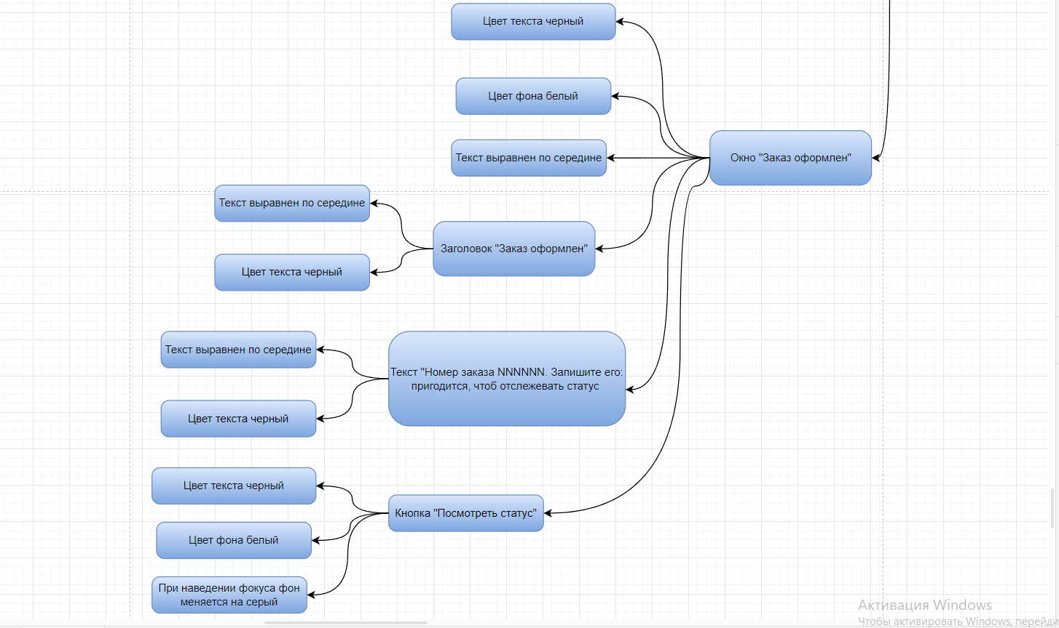

**Логика**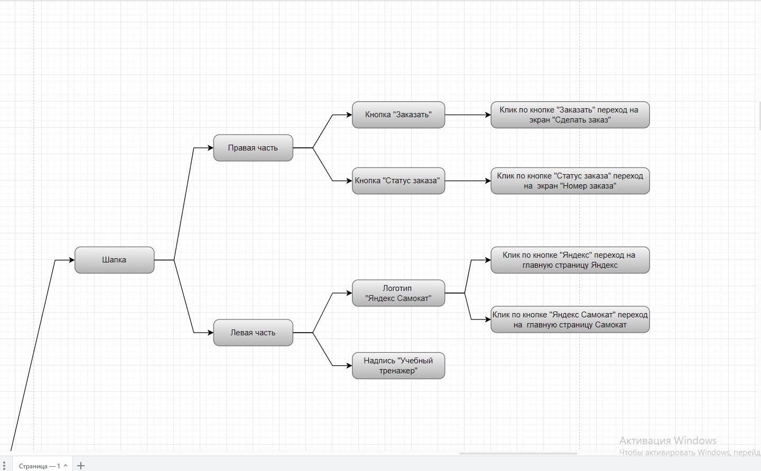

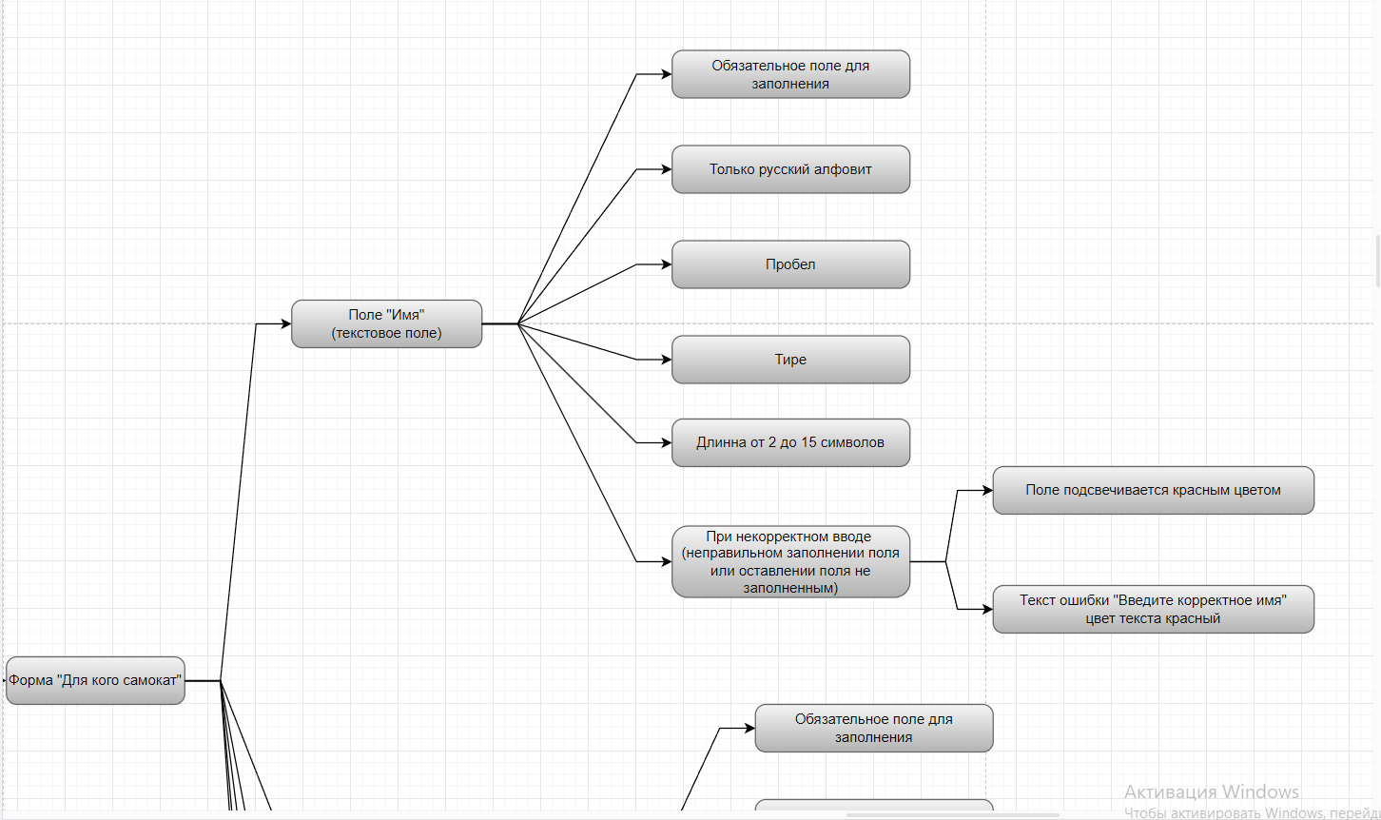

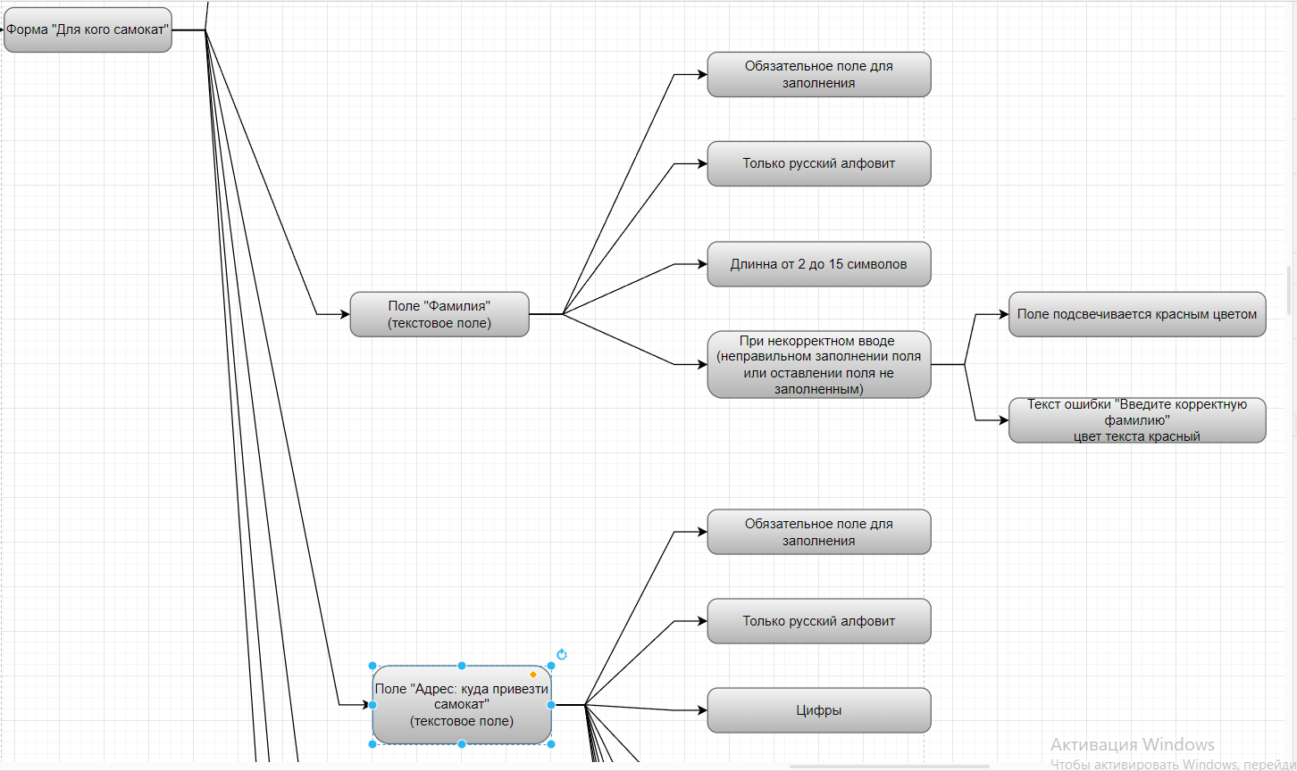

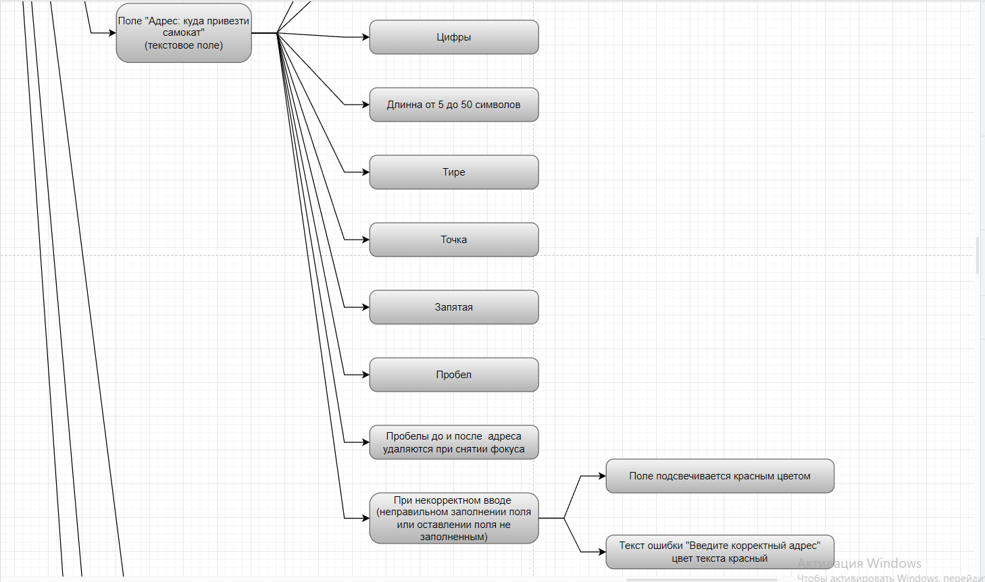

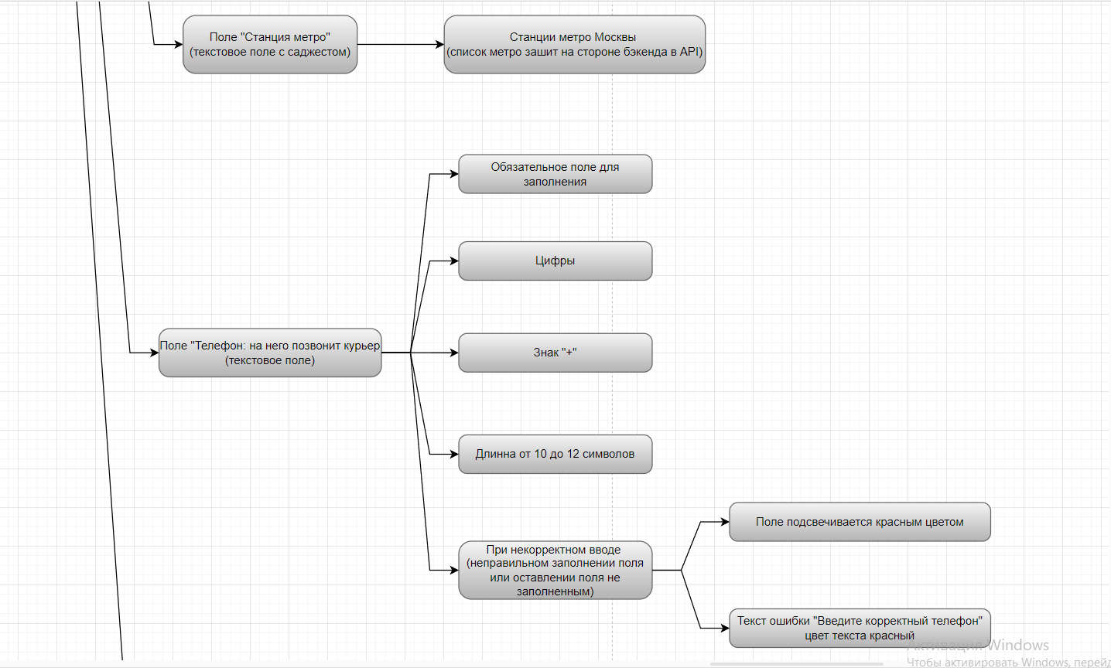

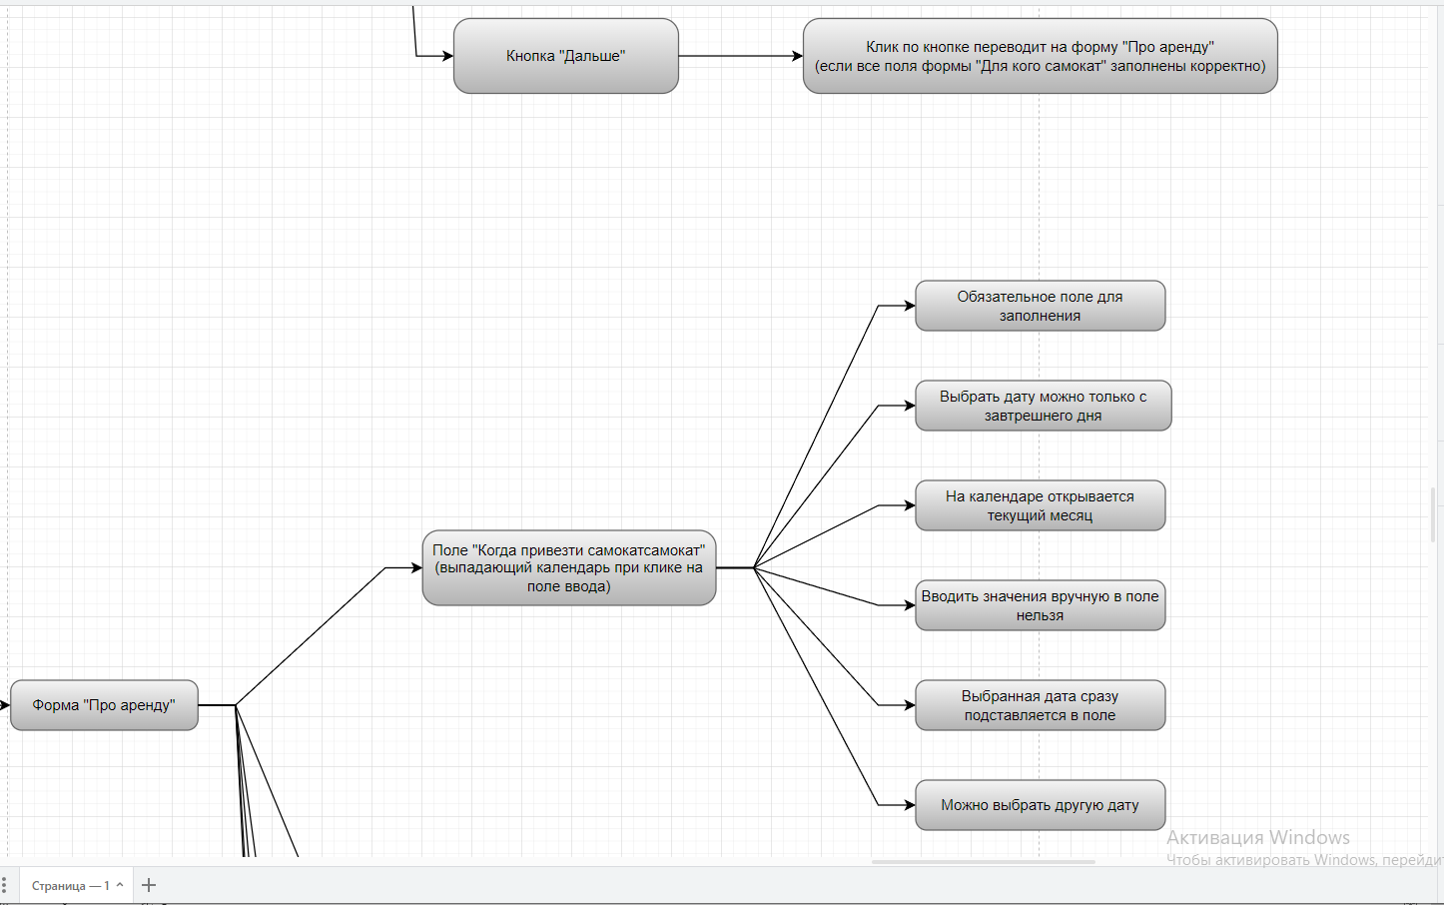

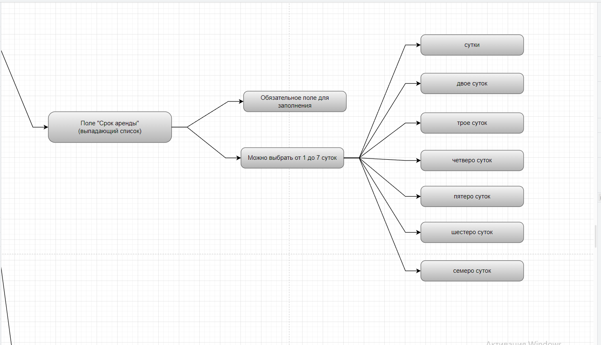

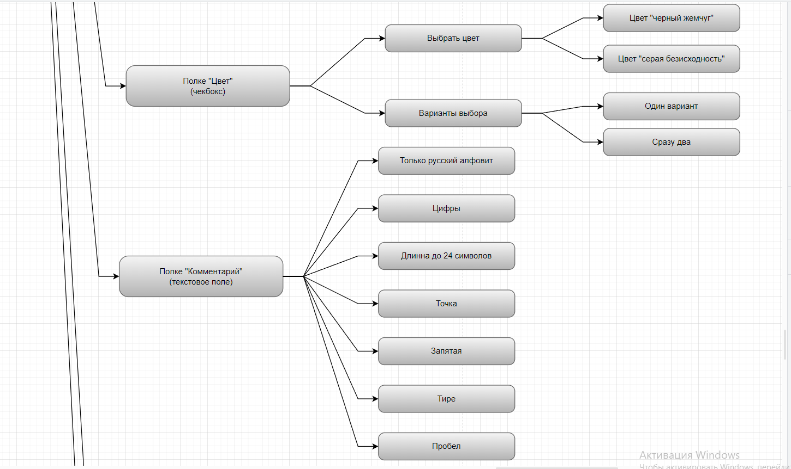

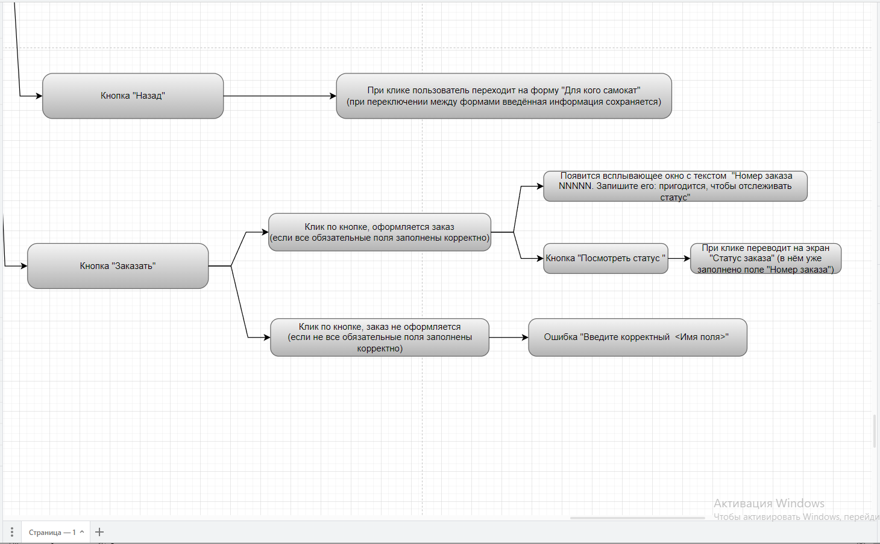

1. Ссылки на баг-репорты, заведённые в трекере:

[https://zubkov31.youtrack.cloud/issues?q=tag:%20%7BДиплом%205%20спринт%7D](https://zubkov31.youtrack.cloud/issues?q=tag:%20%7B%D0%94%D0%B8%D0%BF%D0%BB%D0%BE%D0%BC%205%20%D1%81%D0%BF%D1%80%D0%B8%D0%BD%D1%82%7D)

<https://zubkov31.youtrack.cloud/issue/5V-162/Lishnij-element-knopka-Go-vozle-polya-Nomer-zakaza>

<https://zubkov31.youtrack.cloud/issue/5V-161/Nepravilnoe-nazvanie-polya-vvoda-nomera-zakaza>

<https://zubkov31.youtrack.cloud/issue/5V-163/Prilozhenie-ne-reagiruet-na-nazhatie-knopki-Enter-pri-vvode-nomera-zakaza-v-pole-Nomer-zakaza>

<https://zubkov31.youtrack.cloud/issue/5V-171/Esli-otkryta-stranica-Status-zakaza-pole-Status-zakaza-v-shapke-stranicyne-aktivnoe>

<https://zubkov31.youtrack.cloud/issue/5V-165/Nepravilnoe-izobrazhenie-polomannogo-samokata-na-stranice-Takogo-zakaza-net#okruzhenie>

<https://zubkov31.youtrack.cloud/issue/5V-164/V-informacii-o-zakaze-v-pole-Familiya-tekst-ne-perenositsya-na-vtoruyu-stroku>

<https://zubkov31.youtrack.cloud/issue/5V-166/V-informacii-o-zakaze-v-pole-Adres-tekst-ne-perenositsya-na-vtoruyu-stroku>

<https://zubkov31.youtrack.cloud/issue/5V-180/Cvet-teksta-plejsholdera-polya-Stanciya-metro-chernyj>

<https://zubkov31.youtrack.cloud/issue/5V-243/V-forme-Dlya-kogo-samokat-pri-vybore-stancii-otsutstvuet-cvetovoj-marker-sootvetstvuyushij-vetki-metro>

<https://zubkov31.youtrack.cloud/issue/5V-244/Pri-nazhatii-na-klavishu-Enter-vo-vremya-vybora-stancii-v-pole-Stancii-metro-bloka-Dlya-kogo-samokat-ekran-stanovitsya-belym>

<https://zubkov31.youtrack.cloud/issue/5V-183/Nechitaemyj-shrift-stancij-metro-iz-vypadayushego-spiska-polya-Stanciya-metro-pri-razreshenii-ekrana-1920h1080-v-Yandeks-brauzer>

<https://zubkov31.youtrack.cloud/issue/5V-170/Na-ekrane-Status-zakaza-otobrazhaetsya-ne-ta-stanciya-chto-ukazana-pri-oformlenii-zakaza>

<https://zubkov31.youtrack.cloud/issue/5V-182/Nekorrektnoe-ogranichenie-vypadayushego-spiska-stancij-metro>

<https://zubkov31.youtrack.cloud/issue/5V-247/Tekst-Vvedite-korrektnyj-nomer-vmesto-Vvedite-korrektnyj-telefon>

<https://zubkov31.youtrack.cloud/issue/5V-236/Nepravilnyj-tekst-v-knopkevmesto-Dalshe-nazvanie-knopki-v-forme-Dlya-kogo-samokat-nazyvaetsya-Dalee>

<https://zubkov31.youtrack.cloud/issue/5V-169/Nekorrektnoe-nazvanie-polya-Kogda-privezti-samokat-na-ekrane-Status-zakaza>

<https://zubkov31.youtrack.cloud/issue/5V-241/V-pole-Kogda-privezti-samokat-mozhno-vvesti-tekst-vruchnuyu>

<https://zubkov31.youtrack.cloud/issue/5V-172/Nekorrektnaya-data-dostavki-samokata-na-ekrane-Status-zakaza>

<https://zubkov31.youtrack.cloud/issue/5V-181/Vypadayushij-kalendar-na-ekrane-Pro-arendu-vyravnen-ne-po-pravomu-krayu>

<https://zubkov31.youtrack.cloud/issue/5V-245/V-vypadayushem-kalendare-polya-Kogda-privezti-samokat-bloka-Pro-arenduvyhodnye-dni-ne-otmecheny-krasnym-cvetom>

<https://zubkov31.youtrack.cloud/issue/5V-187/Pri-klike-myshkoj-na-pole-Srok-arendy-granicy-polya-ne-podsvechivayutsya-sinim>

<https://zubkov31.youtrack.cloud/issue/5V-186/Nekorrektnyj-vid-ikoniki-v-vide-strelochki-v-pole-Srok-arendy>

<https://zubkov31.youtrack.cloud/issue/5V-185/Ikonka-v-vide-strelochki-ne-menyaet-svoj-vidostaetsya-napravlena-vnizpri-nazhatii-na-pole-Srok-arendy>

<https://zubkov31.youtrack.cloud/issue/5V-184/Nekorrektnoe-otobrazhenie-vypadayushego-spiska-v-pole-Srok-arendy-ekrane-Pro-arendu>

<https://zubkov31.youtrack.cloud/issue/5V-246/Pri-vybore-variantov-iz-chekboksa-Cvet-samokata-vybrannyj-variant-podsvechivaetsya-sinim>

<https://zubkov31.youtrack.cloud/issue/5V-168/V-informacii-o-zakaze-v-pole-Kommentarij-tekst-ne-perenositsya-na-vtoruyu-stroku>

<https://zubkov31.youtrack.cloud/issue/5V-191/Pri-oformlenii-zakaza-Yandeks.Samokat-est-lishnee-okno-podtverzhdeniya-zakaza>

<https://zubkov31.youtrack.cloud/issue/5V-174/Nekorrektnoe-raspolozhenie-cepochki-statusov-zakazov-na-ekrane-Status-zakaza-v-Yandeks-Brauzere>

<https://zubkov31.youtrack.cloud/issue/5V-242/Zakaz-prinyatyj-kurerom-dubliruetsya-v-baze-dannyh>

<https://zubkov31.youtrack.cloud/issue/5V-175/Ne-otobrazhaetsya-dlinnoe-imya-kurera-v-statuse-zakaza-Yandeks.Samokat>

<https://zubkov31.youtrack.cloud/issue/5V-179/Pri-nazhatii-kurerom-na-knopku-Zavershit-status-Kurer-na-meste-ne-aktiviruetsya>

<https://zubkov31.youtrack.cloud/issue/5V-177/Nevernyj-format-daty-v-statuse-Nu-vsyo-poka-katatsya>

<https://zubkov31.youtrack.cloud/issue/5V-178/Esli-zakaz-prosrochen-menyaetsya-tekst-chetvyortogo-statusa-na-ekrane-Status-zakaza>

<https://zubkov31.youtrack.cloud/issue/5V-176/Kogda-kurer-prinimaet-zakaz-knopka-Otmenit-zakaz-ischezaet>

<https://zubkov31.youtrack.cloud/issue/5V-189/Posle-udaleniya-zakaza-zakaz-ostayotsya-v-sisteme>

<https://zubkov31.youtrack.cloud/issue/5V-188/Okno-podtverzhdeniya-otmeny-zakaza-Zakaz-otmenen-nahoditsya-ne-po-centu-ekrana>

<https://zubkov31.youtrack.cloud/issue/5V-190/Nevozmozhno-oformit-zakaz-v-Yandeks.Samokat-v-brauzere-Google-Chrome>

<https://zubkov31.youtrack.cloud/issue/5V-192/Oshibka-pri-vvode-defisa-v-pole-Imya>

https://zubkov31.youtrack.cloud/issue/5V-193/V-pole-Familiya-mozhno-vvesti-bolshe-15-simvolov

<https://zubkov31.youtrack.cloud/issue/5V-167/Nelzya-vvesti-50-simvolov-v-pole-Adres>

<https://zubkov31.youtrack.cloud/issue/5V-173/Mozhno-oformit-zakaz-bez-adresa-dostavki>

<https://zubkov31.youtrack.cloud/issue/5V-195/Pole-Nomer-telefona-prinimaet-nomer-sostoyashij-iz-13-cifr>

<https://zubkov31.youtrack.cloud/issue/5V-194/V-pole-Nomer-telefona-nelzya-vvesti-nomer-sostoyashij-iz-10-cifr>

<https://zubkov31.youtrack.cloud/issue/5V-196/Pole-Nomer-telefona-prinimaet-nomer-bez>

<https://zubkov31.youtrack.cloud/issue/5V-197/Pri-vybore-daty-dostavki-mozhno-vybrat-segodnyashnyuyu-datu>

<https://zubkov31.youtrack.cloud/issue/5V-199/Pole-Kommentarij-prinimaet-bolshe-24-simvolov>

<https://zubkov31.youtrack.cloud/issue/5V-200/Pole-Kommentarij-prinimaet-bukvy-otlichnye-ot-russkih>

<https://zubkov31.youtrack.cloud/issue/5V-201/Pole-Kommentarij-prinimaet-specsimvoly>

<https://zubkov31.youtrack.cloud/issue/5V-236/Nepravilnyj-tekst-v-knopkevmesto-Dalshe-nazvanie-knopki-v-forme-Dlya-kogo-samokat-nazyvaetsya-Dalee>

<https://zubkov31.youtrack.cloud/issue/5V-241/V-pole-Kogda-privezti-samokat-mozhno-vvesti-tekst-vruchnuyu>

<https://zubkov31.youtrack.cloud/issue/5V-242/Zakaz-prinyatyj-kurerom-dubliruetsya-v-baze-dannyh>

<https://zubkov31.youtrack.cloud/issue/5V-243/V-forme-Dlya-kogo-samokat-pri-vybore-stancii-otsutstvuet-cvetovoj-marker-sootvetstvuyushij-vetki-metro>

<https://zubkov31.youtrack.cloud/issue/5V-244/Pri-nazhatii-na-klavishu-Enter-vo-vremya-vybora-stancii-v-pole-Stancii-metro-bloka-Dlya-kogo-samokat-ekran-stanovitsya-belym>

<https://zubkov31.youtrack.cloud/issue/5V-245/V-vypadayushem-kalendare-polya-Kogda-privezti-samokat-bloka-Pro-arenduvyhodnye-dni-ne-otmecheny-krasnym-cvetom>

<https://zubkov31.youtrack.cloud/issue/5V-246/Pri-vybore-variantov-iz-chekboksa-Cvet-samokata-vybrannyj-variant-podsvechivaetsya-sinim>

<https://zubkov31.youtrack.cloud/issue/5V-247/Tekst-Vvedite-korrektnyj-nomer-vmesto-Vvedite-korrektnyj-telefon>

https://zubkov31.youtrack.cloud/issue/5V-248/Nevozmozhno-oformit-zakaz-v-Yandeks.Samokat-v-Yandeks-brauzere-i-Google-Chrome-kogda-otkryt-DevTools

**Задание 3: Мобильное приложение Яндекс.Самокат**

[https://zubkov31.youtrack.cloud/issues?q=tag:%20%7BДиплом%205%20спринт%7D](https://zubkov31.youtrack.cloud/issues?q=tag:%20%7B%D0%94%D0%B8%D0%BF%D0%BB%D0%BE%D0%BC%205%20%D1%81%D0%BF%D1%80%D0%B8%D0%BD%D1%82%7D)

<https://zubkov31.youtrack.cloud/issue/5V-229/Uvedomlenie-2-chasa-do-konca-zakaza-prihodit-ranshe-polozhennogo-vremeni-v-mobilnom-prilozhenii-Yandeks.Samokat>

<https://zubkov31.youtrack.cloud/issue/5V-230/Uvedomlenie-2-chasa-do-konca-zakaza-prihodit-pozzhe-polozhennogo-vremeni-v-mobilnom-prilozhenii-Yandeks.Samokat>

<https://zubkov31.youtrack.cloud/issue/5V-235/Prihodit-uvedomlenie-2-chasa-do-konca-zakaza-v-mobilnom-prilozhenii-Yandeks.Samokat-pri-otklyuchennom-internet-soedinenii>

<https://zubkov31.youtrack.cloud/issue/5V-237/Prihodit-uvedomlenie-2-chasa-do-konca-zakaza-v-mobilnom-prilozhenii-Yandeks.Samokat-pri-vklyuchennom-avia-rezhime>

<https://zubkov31.youtrack.cloud/issue/5V-238/Push-uvedomlenie-ne-soderzhit-vsyu-neobhodimuyu-informaciyu-o-zakaze>

<https://zubkov31.youtrack.cloud/issue/5V-234/Ne-otobrazhaetsya-ikonka-prilozheniya-v-uvedomlenii-2-chasa-do-konca-zakaza-v-mobilnom-prilozhenii-Yandeks.Samokat>

<https://zubkov31.youtrack.cloud/issue/5V-231/Oshibka-posle-nazhatiya-na-uvedomlenie-v-mobilnom-prilozhenii-Yandeks.Samokat>

<https://zubkov31.youtrack.cloud/issue/5V-232/Nekorrektnyj-tekst-uvedomlenie-ob-otsutstvii-internet-soedineniya-v-mobilnom-prilozhenii-Yandeks.Samokat>

<https://zubkov31.youtrack.cloud/issue/5V-233/Okno-ob-otsutstvii-internet-soedineniya-zakryvaetsya-po-tapu-v-lyuboe-mesto-ekrana-krome-samogo-okna-v-prilozhenii>

**Задание 4: API приложения Яндекс.Самокат**

[https://zubkov31.youtrack.cloud/issues?q=tag:%20%7BДиплом%205%20спринт%7D](https://zubkov31.youtrack.cloud/issues?q=tag:%20%7B%D0%94%D0%B8%D0%BF%D0%BB%D0%BE%D0%BC%205%20%D1%81%D0%BF%D1%80%D0%B8%D0%BD%D1%82%7D)

<https://zubkov31.youtrack.cloud/issue/5V-202/Nekorrektnyj-otvet-201-Created-API-Yandeks.Samokat-mozhno-sozdat-kurera-s-peredachej-parametra-login-POST-api-v1-courier>

<https://zubkov31.youtrack.cloud/issue/5V-204/Nekorrektnyj-otvet-201-Created-API-Yandeks.Samokat-mozhno-sozdat-kurera-s-peredachej-parametra-login-POST-api-v1-courier>

<https://zubkov31.youtrack.cloud/issue/5V-205/Nekorrektnyj-otvet-201-Created-API-Yandeks.Samokat-mozhno-sozdat-kurera-s-peredachej-parametra-login-POST-api-v1-courier>

<https://zubkov31.youtrack.cloud/issue/5V-206/Nekorrektnyj-otvet-201-Created-API-Yandeks.Samokat-mozhno-sozdat-kurera-s-peredachej-parametra-login-POST-api-v1-courier>

<https://zubkov31.youtrack.cloud/issue/5V-211/Nekorrektnyj-otvet-201-Created-API-Yandeks.Samokat-mozhno-sozdat-kurera-s-peredachej-parametra-login-POST-api-v1-courier>

<https://zubkov31.youtrack.cloud/issue/5V-212/Nekorrektnyj-otvet-201-Created-API-Yandeks.Samokat-mozhno-sozdat-kurera-s-peredachej-parametra-login-POST-api-v1-courier>

<https://zubkov31.youtrack.cloud/issue/5V-213/Nekorrektnyj-otvet-201-Created-API-Yandeks.Samokat-pri-sozdanii-kurera-s-peredachej-parametra-password-POST-api-v1-courier>

<https://zubkov31.youtrack.cloud/issue/5V-214/Nekorrektnyj-otvet-201-Created-API-Yandeks.Samokat-pri-sozdanii-kurera-s-peredachej-parametra-password-POST-api-v1-courier>

<https://zubkov31.youtrack.cloud/issue/5V-209/Nekorrektnyj-otvet-201-Created-API-Yandeks.Samokat-pri-sozdanii-kurera-s-peredachej-parametra-password-POST-api-v1-courier>

<https://zubkov31.youtrack.cloud/issue/5V-207/Nekorrektnyj-otvet-201-Created-API-Yandeks.Samokat-pri-sozdanii-kurera-s-peredachej-parametra-password-POST-api-v1-courier>

<https://zubkov31.youtrack.cloud/issue/5V-208/Nekorrektnyj-otvet-201-Created-API-Yandeks.Samokat-pri-sozdanii-kurera-s-peredachej-parametra-password-POST-api-v1-courier>

<https://zubkov31.youtrack.cloud/issue/5V-210/Nekorrektnyj-otvet-201-Created-API-Yandeks.Samokat-pri-sozdanii-kurera-s-peredachej-parametra-password-POST-api-v1-courier>

<https://zubkov31.youtrack.cloud/issue/5V-222/Nekorrektnyj-otvet-201-Created-API-Yandeks.Samokat-pri-sozdanii-kurera-s-peredachej-parametra-password-POST-api-v1-courier>

<https://zubkov31.youtrack.cloud/issue/5V-223/Nekorrektnyj-otvet-201-Created-API-Yandeks.Samokat-pri-sozdanii-kurera-s-peredachej-parametra-password-POST-api-v1-courier>

<https://zubkov31.youtrack.cloud/issue/5V-215/Nekorrektnyj-otvet-201-Created-API-Yandeks.Samokat-pri-sozdanii-kurera-s-peredachej-parametra-password-POST-api-v1-courier>

<https://zubkov31.youtrack.cloud/issue/5V-216/Nekorrektnyj-otvet-201-Created-API-Yandeks.Samokat-pri-sozdanii-kurera-s-peredachej-parametra-password-POST-api-v1-courier>

<https://zubkov31.youtrack.cloud/issue/5V-217/Nekorrektnyj-otvet-201-Created-API-Yandeks.Samokat-pri-sozdanii-kurera-s-peredachej-parametra-password-POST-api-v1-courier>

<https://zubkov31.youtrack.cloud/issue/5V-218/Nekorrektnyj-otvet-201-Created-API-Yandeks.Samokat-pri-sozdanii-kurera-s-peredachej-parametra-password-POST-api-v1-courier>

<https://zubkov31.youtrack.cloud/issue/5V-220/Nekorrektnyj-otvet-201-Created-API-Yandeks.Samokat-pri-sozdanii-kurera-s-peredachej-parametra-password-POST-api-v1-courier>

<https://zubkov31.youtrack.cloud/issue/5V-219/Nekorrektnyj-otvet-201-Created-API-Yandeks.Samokat-pri-sozdanii-kurera-s-peredachej-parametra-password-POST-api-v1-courier>

<https://zubkov31.youtrack.cloud/issue/5V-221/Nekorrektnyj-otvet-201-Created-API-Yandeks.Samokat-pri-sozdanii-kurera-s-peredachej-parametra-password-POST-api-v1-courier>

<https://zubkov31.youtrack.cloud/issue/5V-224/Nekorrektnyj-otvet-201-Created-API-Yandeks.Samokat-pri-sozdanii-kurera-s-peredachej-parametra-password-POST-api-v1-courier-ne>

<https://zubkov31.youtrack.cloud/issue/5V-226/Pri-udalenii-kurera-v-API-Yandeks.Samokat-svyazannyj-s-nim-zakaz-ostayotsya-v-tablice-Orders.-DELETE-api-v1-courier-id-200-OK>

<https://zubkov31.youtrack.cloud/issue/5V-240/Kod-404-i-status-Not-Found-pri-otpravke-DELETE-api-v1-courier-id-zaprosa-bez-ukazaniya-id-na-udalenie-kurera>

<https://zubkov31.youtrack.cloud/issue/5V-239/Oshibka-v-strukture-otveta-pri-otpravke-DELETE-api-v1-courier-id-zaprosa-s-nesushestvuyushim-id-na-udalenie-kurera>

<https://zubkov31.youtrack.cloud/issue/5V-227/Nekorrektnaya-struktura-otveta-v-zaprose-GET-api-v1-orders-trackt-API-Yandeks.Samokat>